PC2232
Some MCQs on Schrodinger Equation

- A,B,C,D and E, where will you most likely find the particle?
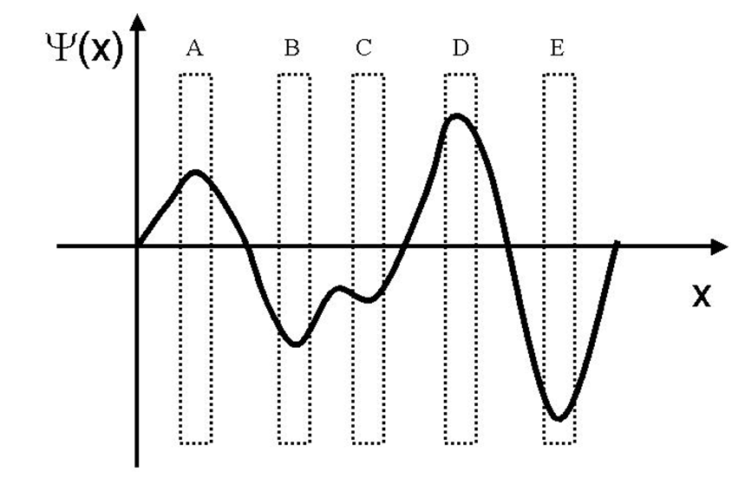
Answer: E

- The following plot shows a wavefunction Ψ(x) of a particle. Five different regions were selected as shown in the figure. Arrange the regions according to descending probability of finding the particle. i.e. from the region where you will most likely find the particle to region where you will least likely find the particle.
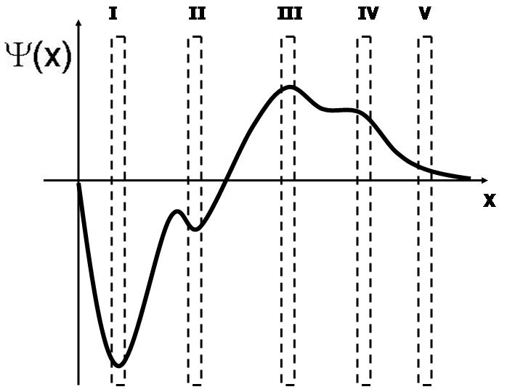

  - I, II, V, IV, III.
  - III, IV, V, II, I.
  - III, IV, II, V, I.
  - I, III, IV, II, V.
  - I, II, III, IV, V.
Answer: D

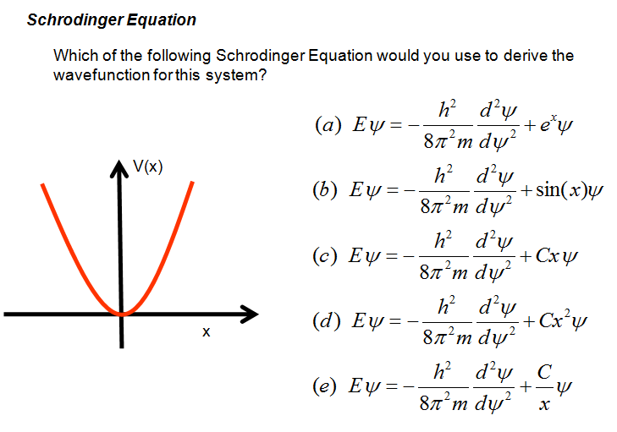
Answer: D

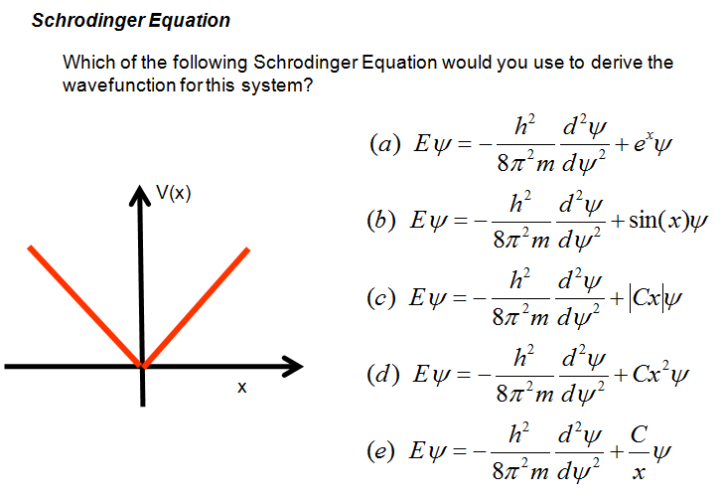
Answer: C

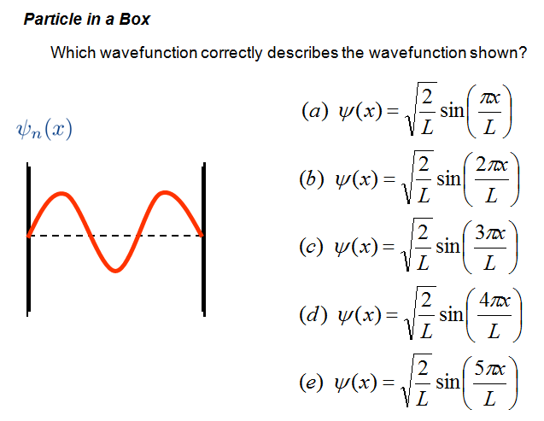
Answer: C

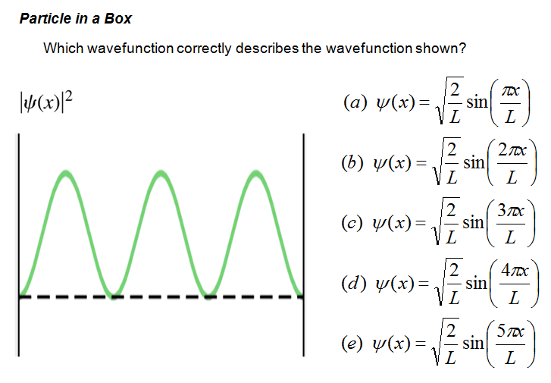
Answer: C

- A particle was trapped in a 1D potential box with width L. A photon with the energy of 5h²/[8mL²] was emitted. What happen to the particle? (let n = quantum number)
  - It went from n=2 state to n=3 state.
  - It went from n=3 state to n=2 state.
  - It went from n=1 state to n=6 state.
  - It went from n=6 state to n=1 state.
  - It went from n=7 state to n=2 state.
Answer: B

- An electron is confined within a thin layer of a semiconductor. If the layer can be treated as an infinitely deep one-dimensional potential well, calculate its thickness if the difference in energy between the first (n=1) and second (n=2) levels is 0.05 eV.
  - 6.1 nm.
  - 5.5 nm.
  - 4.8 nm.
  - 3.9 nm.
  - 2.7 nm.
Answer C

- An electron with mass m is confined within a one-dimensional potential box with length L and infinite potential on both sides. Initially the electron is in an excited state with quantum number n=5. After a short while, a photon is emitted. What is the largest possible energy of the emitted photon?
  - 25h²/[8mL²].
  - 24h²/[8mL²].
  - 21h²/[8mL²].
  - 16h²/[8mL²].
  - 9h²/[8mL²].
Answer B

- If some particles in a 1D potential box bounded by barriers with infinite potential energy are initially found in the excited state with n=5. The particles eventually return to the ground state after emitting one or more photons. How many different types of photons will be emitted? (Here photons with different wavelengths are classified as different types.)
  - 1.
  - 4.
  - 5.
  - 7.
  - 10.
Answer E

- Photon emitted as a result of a particle de-excite from higher level to ground state from one potential box of width L was used to excited another particle in another potential box of width D as shown. What is the ratio of the width L/D if the mass of the particles is the same?

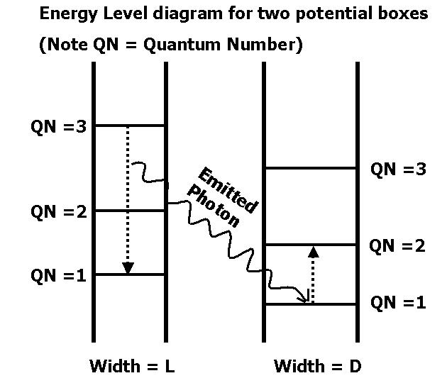

  - 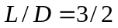.
  - 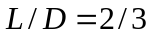.
  - 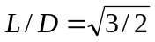.
  - 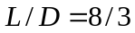.
  - 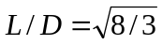.
Answer E

- Which of the following systems will not give rise to quantization of energy?
  - Electron in a potential box with infinite potential barriers.
  - Electron orbiting a positively charged nucleus.
  - Electron in a bowl-shape potential.
  - Electron moving freely in three-dimensional space.
  - All of the above will give rise to quantization of energy.
Answer D

- Which of the following statements is not true regarding particle in a 1D potential box with a width of L as shown in the following diagram?

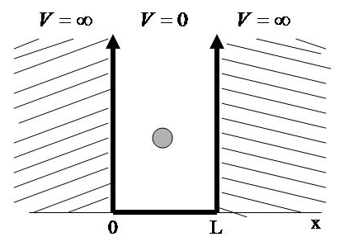

  - The energy of the particle in the ground state is inversely proportional to the square of the width.
  - Particle P1 is in its ground state in this potential box. P2 is another particle in a different potential box with a width of 2L but P2 has the same energy as P1. One can conclude that P2 is in its excited state with n=4.
  - The probability of finding the particle is the region defined by x < -5 is equal to zero.
  - Dividing the region within 0<x<L equally into seven regions, denote the regions, starting from left, as R1, R2, R3, R4, R5, R6 and R7. If the particle is in its ground state, the region that one would most likely find the particle is R4.
  - The energy difference between one energy level and the next higher energy level increases with increasing quantum number n.

Answer B

- The following figure shows another way to depict the particle in a potential box. What should be the wavefunction of the ground state? What is the expression of the quantization of the energy?
